Results of Simulink model of the robot:

Yes, the answers are logical after loopings over different angles to know the start position of every link and then we are able to illustrate all the outputs of the functions and visualize the movements of the robot with only inserting its inputs.

Case(1) :

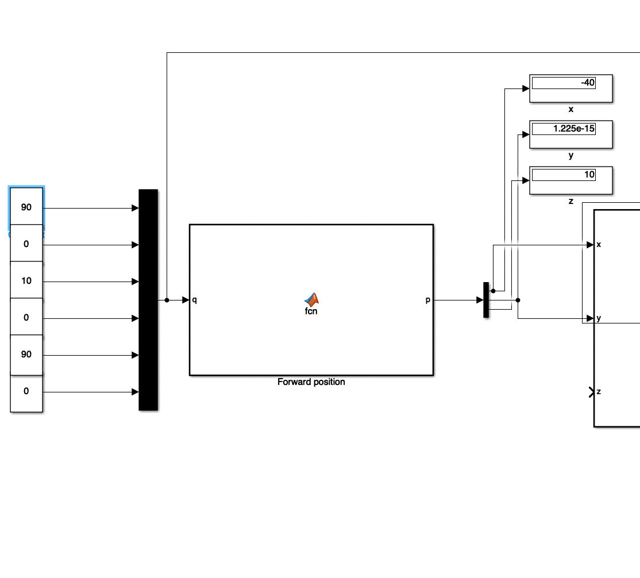

* All links are assumed to be 10 unit.
* The total lengths of the robot is 10+10+10+10 =40 , in addition to a 10 of a positive translational movement from q3, so the total length will be 40+10=50.
* And each joint is given an input angle to make it stretched for the maximum position at x and it was 40, as it will be as (L) shaped with a height of 10 in positive Z and 40 in x.

Case(2):

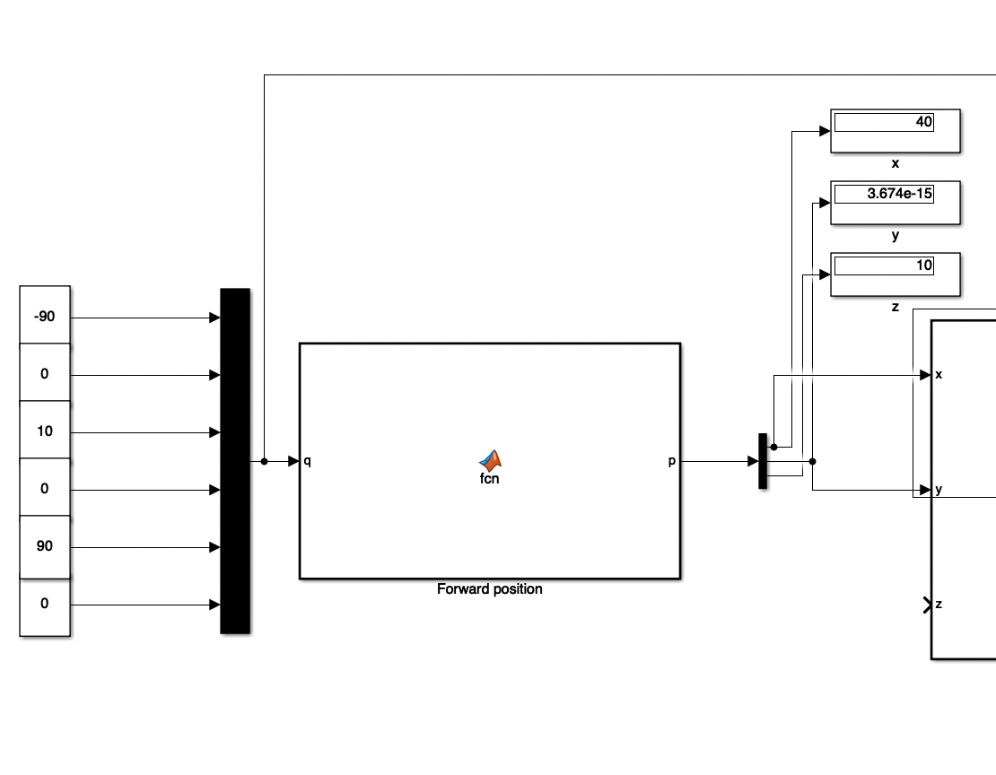

* The same as case (1), but the angle of the first joint (q1) will be -90 instead of (90), so the only difference is that the maximum position in x will be in positive 40.

Case(3):

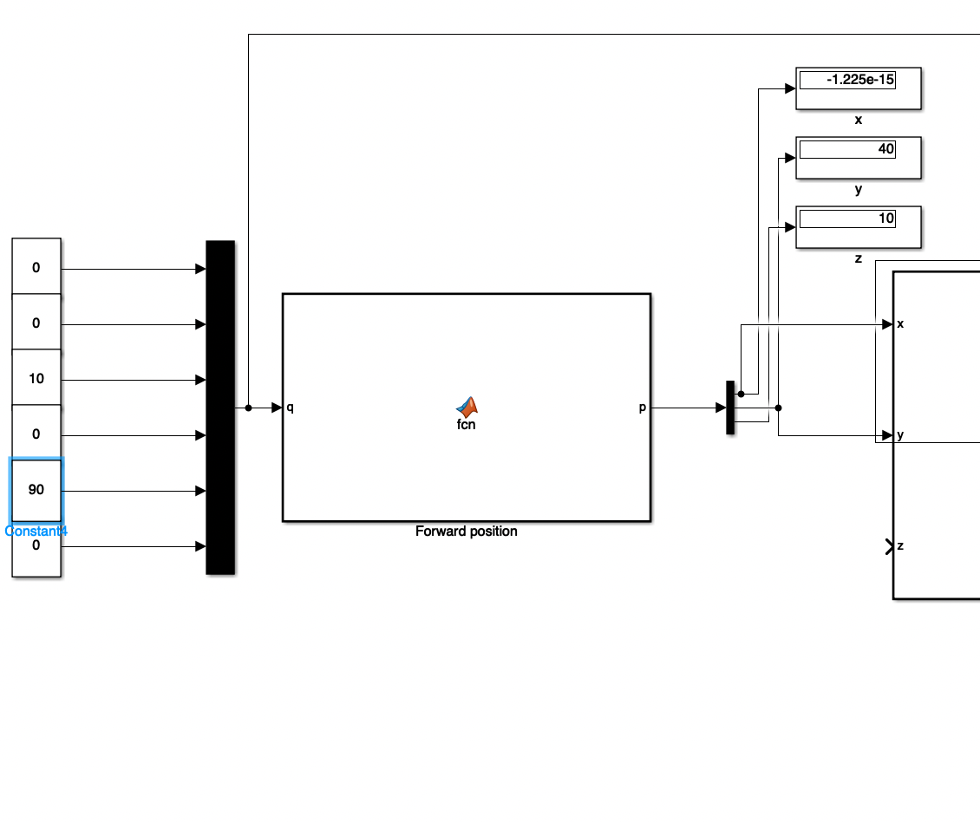

* All links are assumed to be 10 units.
* The total lengths of the robot is 10+10+10+10 =40 , in addition to a 10 of a positive translational movement from q3, so the total length will be 40+10=50.
* And each joint is given an input angle to make it stretched for the maximum position at y. and it was 40, as it will be as (L) shaped with a height of 10 in Z and 40 in the positive of y.

The value in x is due to calculations in matlab but it converges to zero.

Case(4):

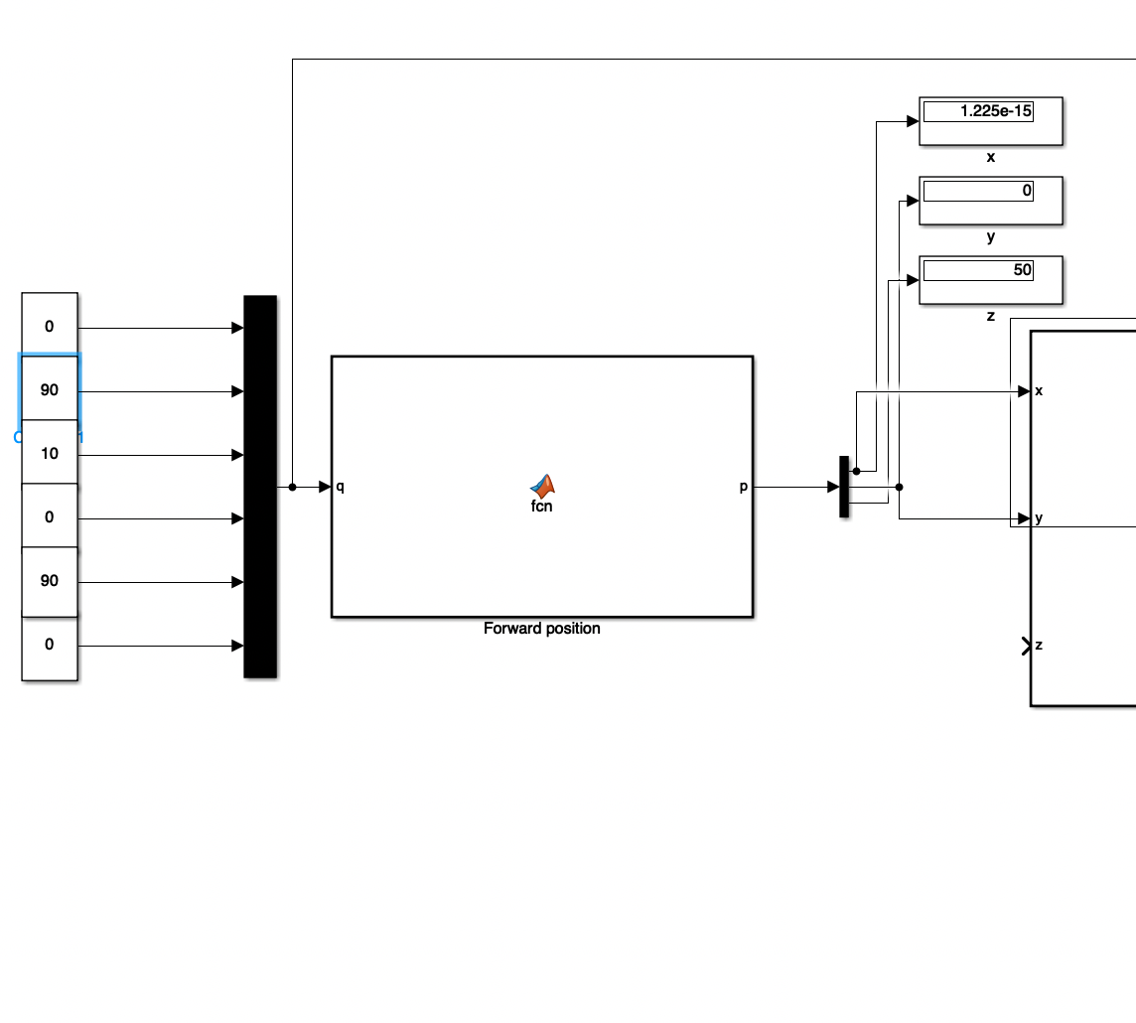

* All links are assumed to be 10 units.
* The total lengths of the robot is 10+10+10+10 =40 , in addition to a 10 of a positive translational movement from q3, so the total length will be 40+10=50.
* And each joint is given an input angle to make it stretched for the maximum position at z. and it was 50, as it will be as straight shaped (as one line of summations of lengths ) with a height of 50 in positive Z.

The value of shown x is due to calculations in matlab but it converges to zero.